State Driven Camera

To change camera behaviours depending upon the animating state of a player.

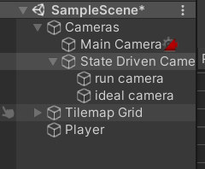

State Driven Camera created from cinemachine window tab.

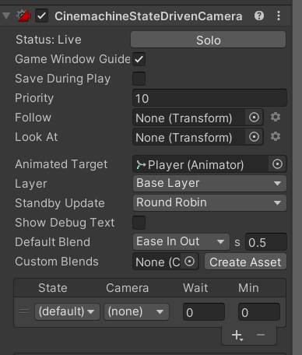

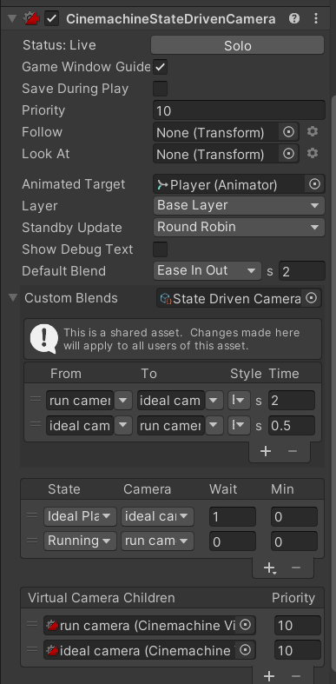

Custom Blends to change the transition state of camera for each child cameras

Specified the number of cameras with their respective desired states